**Assignment 3**

1. Create a module called validate.py which has the following functions to:

* Create and return an OTP of 4 digits using the functions from random module.
* Create and return a Captcha of length as per requirement – comprising a digit, an uppercase letter, a lowercase letter and a special character.
  + Default length = 4 (one of each).
  + Handle the case when the user enters a length less than 4.
  + If the user enters length > 4, then you can choose to repeat any of the 4(digit / uppercase / lowercase/ spl.char) at random to satisfy the required length. Make sure one of each is definitely part of the Captcha.
* Check the validity of an email id
  + Email should definitely contain only one @.
  + The part before @ should not have spaces (prefix)
  + The part after @ should contain one or two ‘.’ (domain)
  + If there’s one dot, then the number of characters after domain name should be 3
  + If there are 2 dots, then the number of characters after the second dot should be 2.
  + The domain can have letters, numbers, dashes.

**[Hint: You can import re module to check validity of email]**

          [ Invalid emails:

@mail.com

abmail.org

a.b@.net

a.b43@mail

a..b@mail.com

ab@mail#archive.com ]

Include this module in your program and based on a menu call the respective functions.

1. Use the urllib module to access any website(python.org) and read the html.

Find references to links to other websites in the html and list them out.

1. Use the tkinter library to create a window in the following manner:

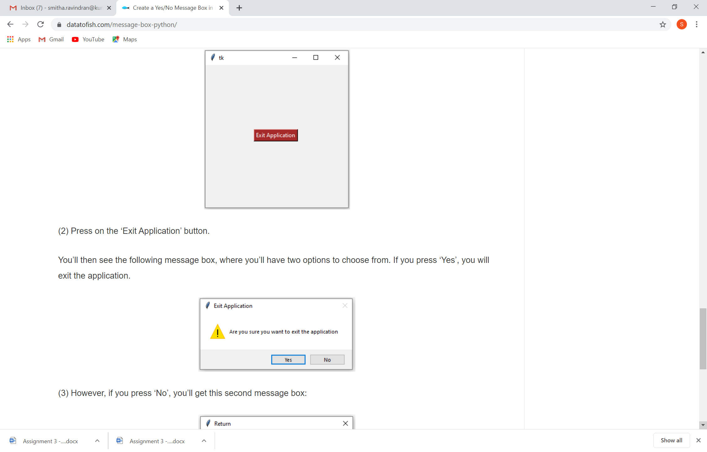

On pressing exit application the user should get a message such as:

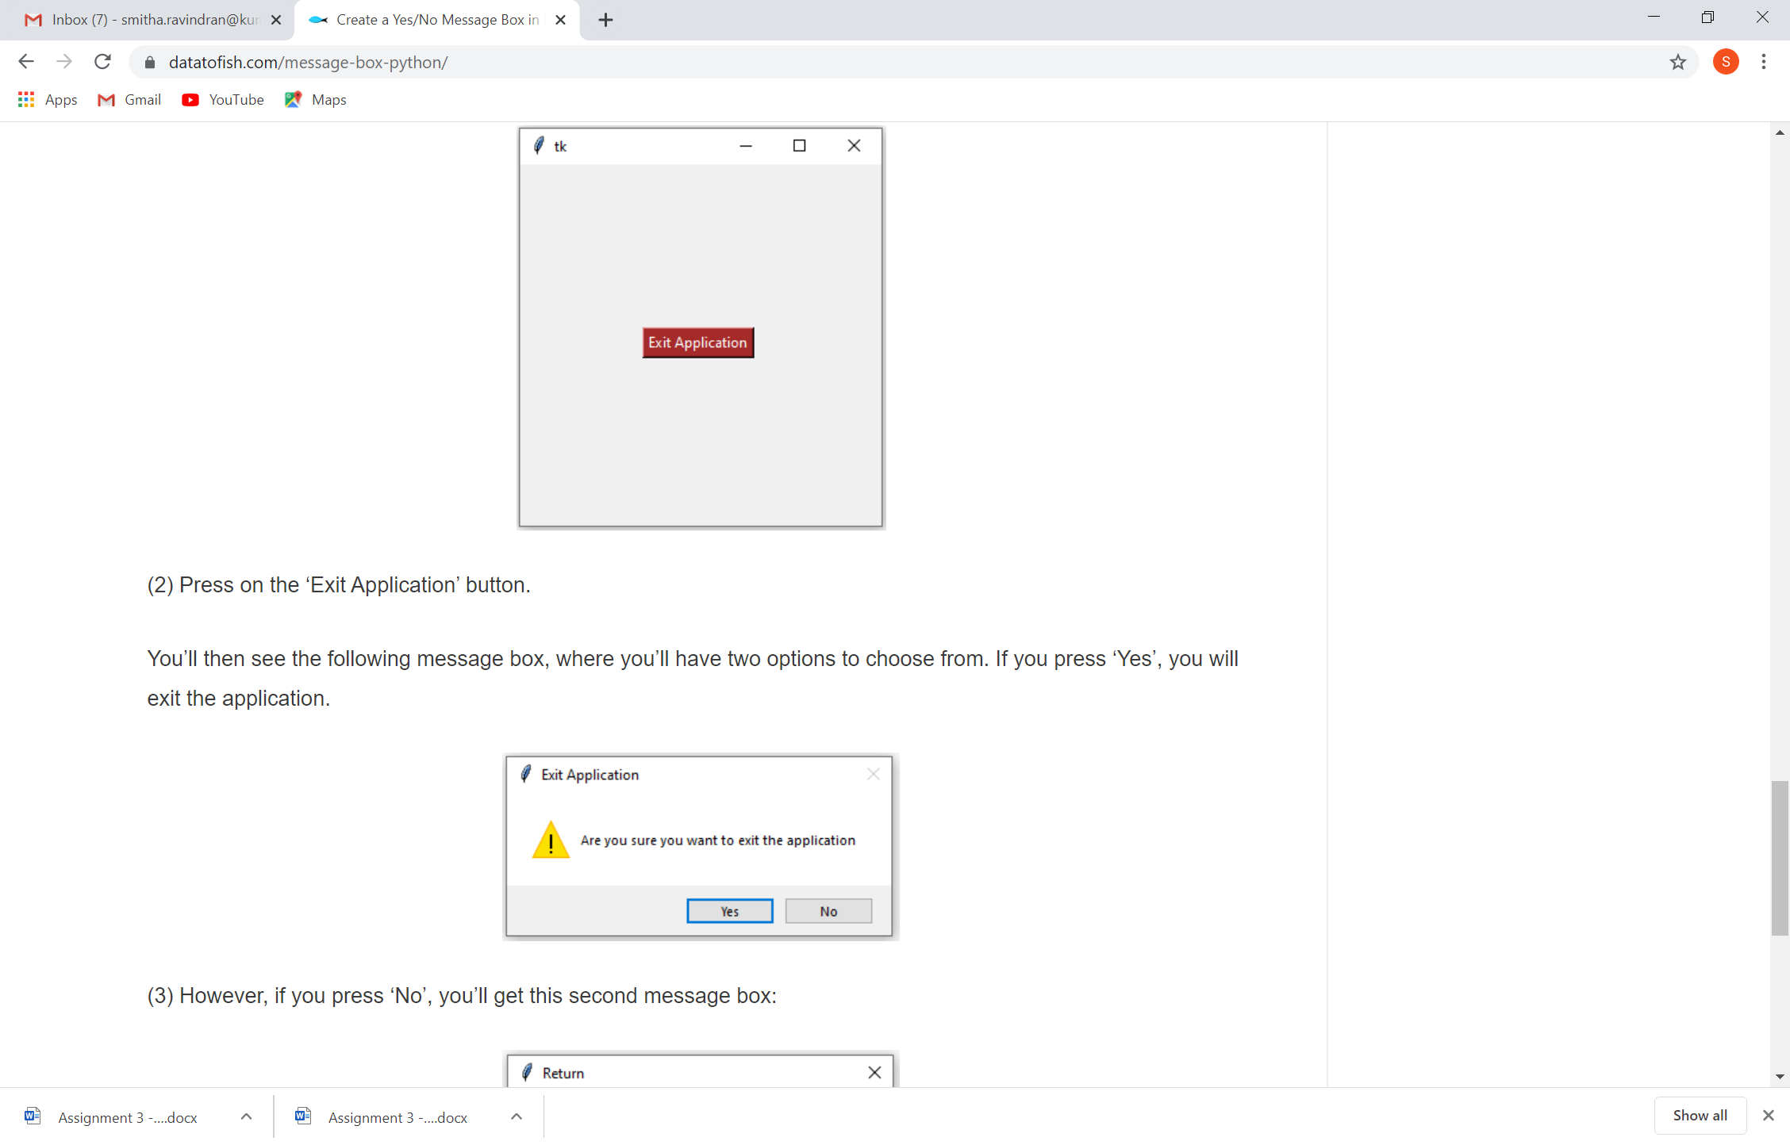

If yes , exit otherwise keep the screen.

1. Given a date find the number of days between the given date and the current date. (Find the library function to do this)
2. Taking the current time in India calculate the time in
   1. New York (9 hours 30 minutes behind Calcutta)
   2. Sydney(5 hours 30 minutes ahead of Calcutta)
   3. Johannesburg ( 3 hours 30 minutes behind Calcutta)

Display the time in 24 hours format.

(Use necessary libraries)